Assignment 3: Emerging Technologies & Career Exploration

Subject : Computer Science Fundamentals , Career Pathways (ETCCCP105)

Faculty : Mr. Ravinder Beniwal

Programme : B.Tech CSE(FSD)|semester:1

Student Name : Tarun Kumar Chaurasia

Roll No:2501350067

Introduction to the Domain
The Internet of Things (IoT) represents a transformative technology domain where everyday physical devices are connected to the internet through embedded sensors and software. These "smart" devices communicate and exchange data, enabling automation, improved efficiency, and novel user experiences. IoT integrates hardware, networking, data analytics, and cloud computing to drive innovations across various sectors including healthcare, agriculture, manufacturing, transportation, and urban infrastructure. Its impact is profound in creating smarter environments and improving decision-making via real-time data.

PPT
On
Internet Of Things(IOT)

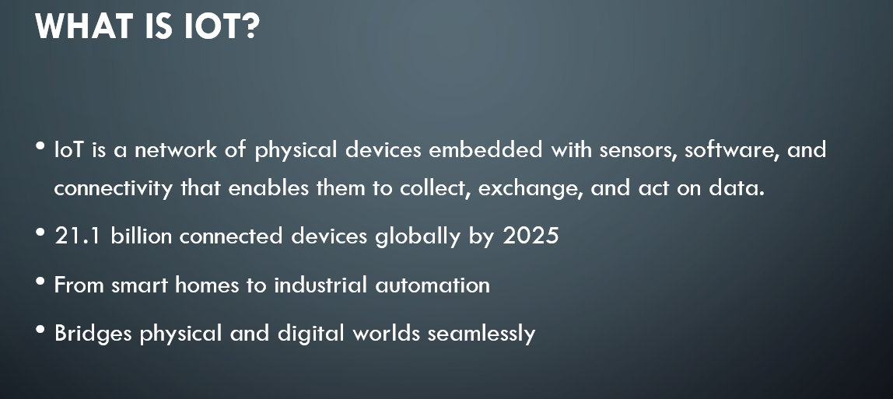

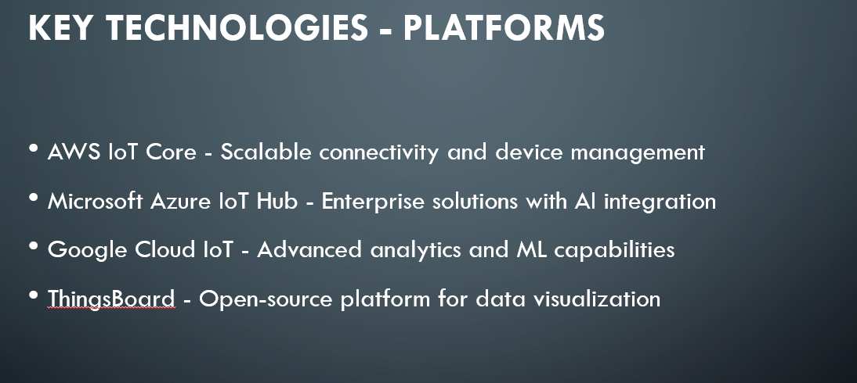
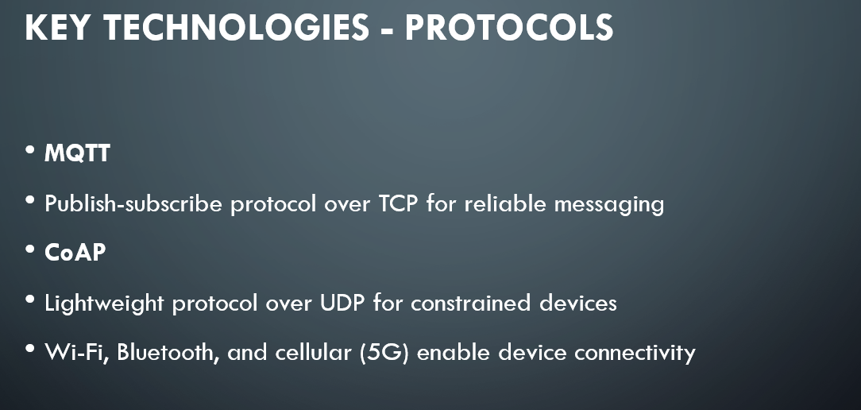
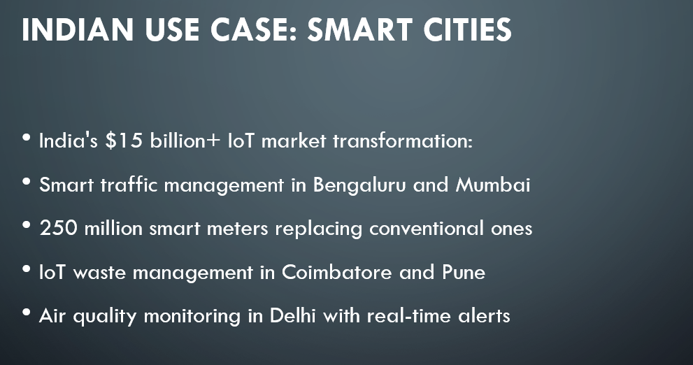

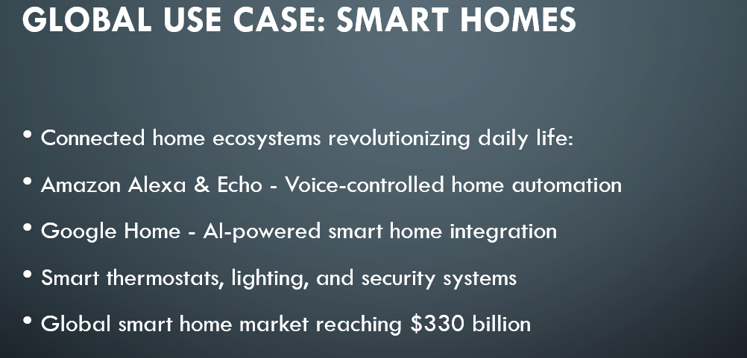
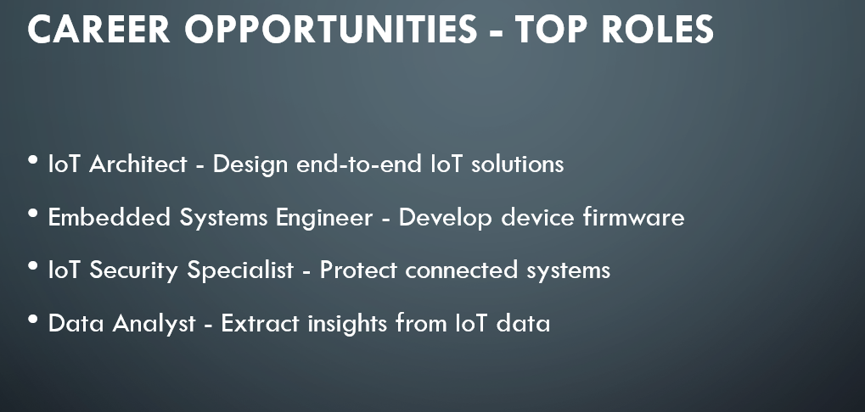

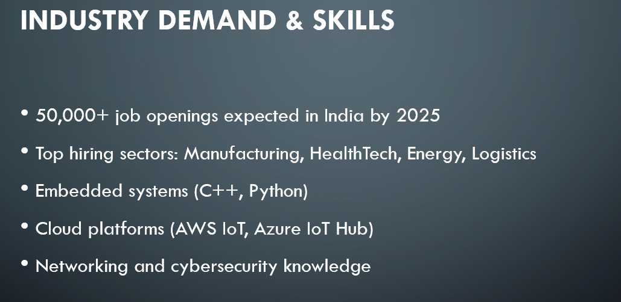
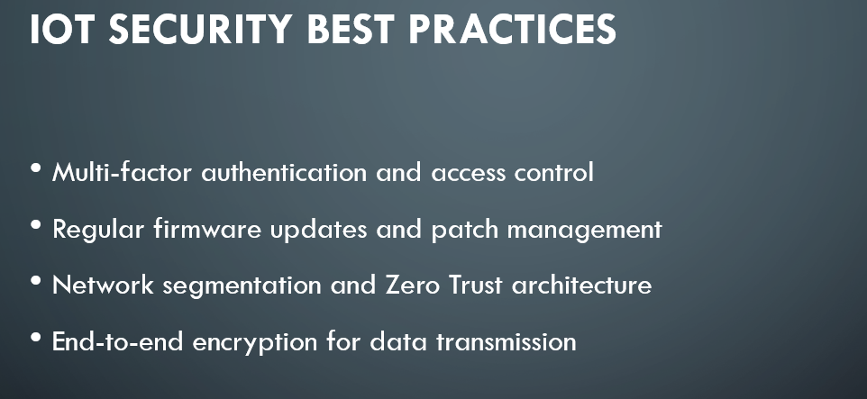



Research Findings
- Key Technologies
IoT technologies revolve around several core components including :
- IoT Platforms: Market-leading platforms in 2025 include AWS IoT, Microsoft Azure IoT Hub, Google Cloud IoT Core, and Samsung Artik Cloud. They provide critical services such as device provisioning, data ingestion, analytics, and security management .
- Communication Protocols: Efficient and lightweight protocols are essential for IoT device communication. MQTT (Message Queuing Telemetry Transport) is widely used for low-bandwidth device messaging, CoAP (Constrained Application Protocol) caters to constrained devices, and HTTP/HTTPS supports web integration .
- Devices and Sensors: Embedded microcontrollers and sensor modules gather environmental, operational, or user data. Examples include temperature sensors, motion detectors, GPS modules, and cameras.
- Security: Ensuring secure communication and data privacy is paramount. Key measures include encryption, multi-factor authentication, firmware updates, network segmentation, and anomaly detection systems.

2.Real-World Use Cases
- Indian Example: IoT is a backbone technology for smart city projects in India, such as the Smart Cities Mission initiatives in Bangalore, Pune, and Hyderabad. Applications include smart traffic management systems that monitor and regulate vehicle flow, waste management using sensor-enabled bins, environmental pollution tracking, and intelligent street lighting to conserve energy and enhance safety.
- Global Example: On a global scale, smart homes powered by IoT devices like Amazon Alexa and Google Nest allow users to control lighting, heating, security cameras, and entertainment systems via voice commands and mobile apps. These ecosystems increase convenience, energy efficiency, and home security worldwide.
3.Career Opportunities
IoT opens a diverse and growing range of career paths owing to its cross-disciplinary nature:
- Job Roles: IoT Developer, Embedded Systems Engineer, IoT Architect, IoT Security Specialist, Data Scientist, Cloud Solutions Architect, and Network Engineer.
- Industry Demand: The global IoT market is projected to expand rapidly, driven by smart cities, industrial IoT, connected vehicles, and healthcare monitoring systems. Indian startups and tech companies are also increasingly adopting IoT solutions, creating local job opportunities.
- Required Skills: Proficiency in programming languages such as Python, C, and JavaScript; knowledge of IoT platforms (e.g., AWS IoT, Azure IoT); expertise in network protocols (MQTT, CoAP); experience with embedded systems, sensors, and hardware interfacing; skills in data analytics and cloud computing; and a sound understanding of IoT security practices.

Reflection
The IoT domain aligns strongly with my academic and career goals as a computer science student interested in emerging technologies and connected systems. IoT's integration of software and hardware presents an exciting challenge that combines my coding skills with real-world applications. I already have experience in Python programming and web development, which provides a solid foundation to work with IoT platforms and cloud services.Moving forward, I aim to develop skills in microcontroller programming and embedded systems to better understand low-level device behavior. Additionally, I want to build expertise in communication protocols and IoT security to address the growing concern over data privacy and system resilience. Understanding how IoT devices interface with cloud platforms and use data analytics will also prepare me to design comprehensive IoT applications. Overall, exploring IoT opens numerous avenues for interdisciplinary innovation and career growth, particularly in smart cities and industrial automation.

